Following the second “Moon Ape” incident, Rovod was infected with a were-ape curse. Atir (her son) was at a tender age of 10 months old at the time. The law dictates that all confirmed infections need to be permanently separated from the population. And so, a decision was made to offer cave exile to the infected. Cave exile is the tradition of sending out those marked for death in to the cave system, without a pick. The hope was that in the caves they would find a more meaningful death than an execution.
A total of 5 members of the Delightful Lanterns were bitten in the first and second incident. One openly refused cave exile, and was walled in to the hospital wall. Uncapable of expiring due to her curse, her future fate is yet to be decided.
As soon as the four that claimed to be willing to face death in the caves started making their way, Rovod broke of, and with the help of her husband Fath escaped the confines of the Fortress. Since a full moon was right around the corner an attempt to recover them was not made, in fear of complications and further bloodshed. To be frank – the real reason no one chased her was because no one wanted to see a mother turn in to a monster and tear her baby to shreds.
In order to prevent panic in the general population, her infection was made hidden, and instead all three escapees were declared banished, with a fake political excuse made as the reason.
Somehow, all three escapees managed to make their way far south – alive - to the remote hillocks of Oilmatches.
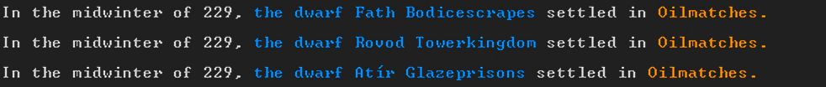
The other three infected have been wondering the caverns for months. Their minimalistic screams can be still heard sometimes when the moon is full.

